**Style Visual Story (for an online hearing)**

**My tribunal hearing**

My tribunal hearing will take place on **Monday 5 April and Tuesday 6 April 2025.**

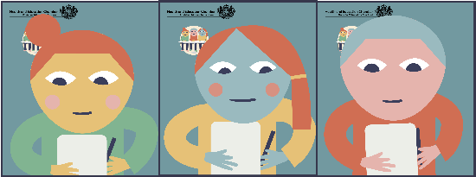

**How will it happen?**

* The tribunal hearing will take place online with everyone using computers to communicate and see each other.
* There will be 3 tribunal members – a legal member and two other members who are experienced in education, health or social work. They are independent. This means that they have nothing to do with my school or anyone else I know.
* You will know who the tribunal members are because they will have the same screen backdrop (like the image above). They will also tell you their names on the day.



**Speaking at the tribunal - the witness**

* During the tribunal hearing, only one person speaks at a time. Everyone else listens to what they have to say.

* + - The person giving evidence is called **the witness**. Other people will take it in turns to ask that person questions. The legal member will tell me who will be asking the questions.
* I can’t interrupt even if I don’t agree with what they are saying. The reason for this is so that everyone has their say.**My turn**
* After the other witnesses have spoken, on day 2, I will get my chance to be the witness and say what I think and feel and everyone will concentrate and listen to me.
* When it’s my turn to be the witness, I will be asked some questions. The tribunal members just want to know what I think and feel. The questions are not meant to be hard or to trick me.



**Breaks**

* Throughout the day there will be breaks. The hearing will stop no later than 4 o’clock each day.
* I can ask for a break. My supporter will be with me to help.

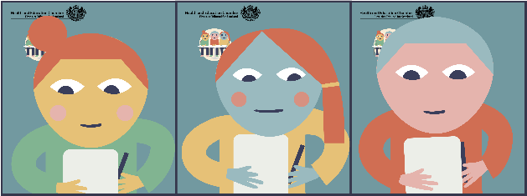

**Remember**

* The people at the tribunal hearing won’t be smiling a lot.
* This doesn’t mean they are angry, annoyed or unfriendly. It means they are concentrating and listening.
* The people won’t be looking at the screen all the time. They will be looking down a lot of the time.
* This doesn’t mean they aren’t concentrating or listening. It is because they are writing down notes so that they remember everything clearly afterwards.

**What will people say?**

* I will hear a lot of things being said about me and my education. I will probably agree with a lot of it. The witnesses might also say things I disagree with. They might say things that annoy me or upset me.
* **Remember**… I can’t interrupt at that point but I know I will get my chance to have my say and put across my point of view later on.



**Don’t be anxious or stressed**

* I can attend my tribunal hearing without feeling too anxious or stressed now that I know what it will be like.